**Experiment No-10**

**Name : Rajashri Jaywant Patil**

**Title : PL/SQL program on A)Creating Cursor, B) Creating trigger.**

1. **Creating Cursor-**

**Create Table-**

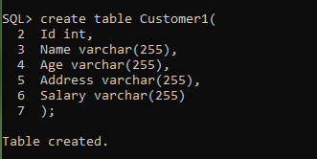

**Insert Record-**

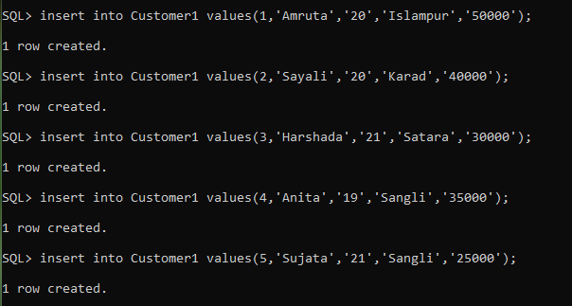

* **Implicit Cursor-**

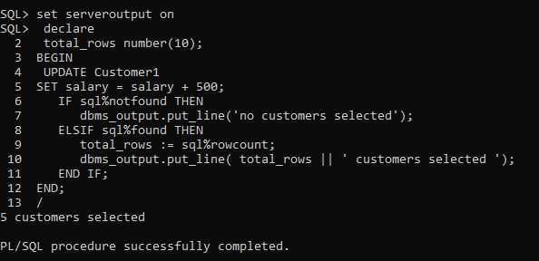

* **Explicit Cursor-**

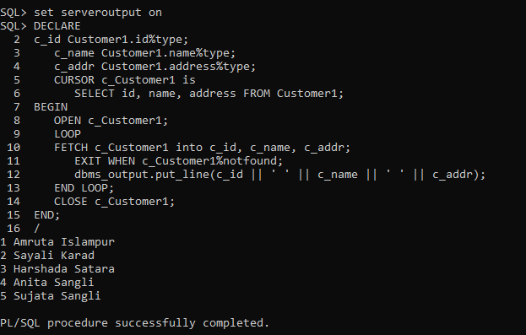

1. **Creating Trigger-**

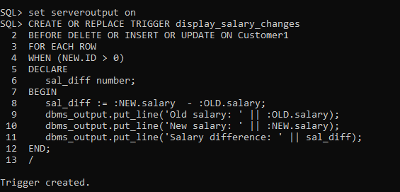

**Insert**

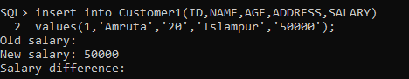

**Update-**

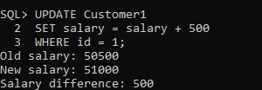

**Delete-**

